Assignment (3.4)

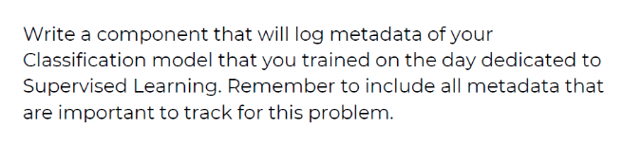
Solution

- Setting up MLFlow tracking server
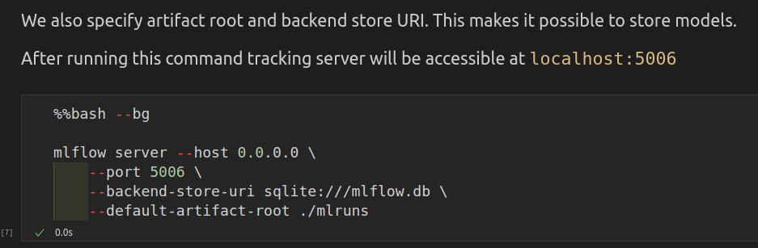

- Now make MLProject file.

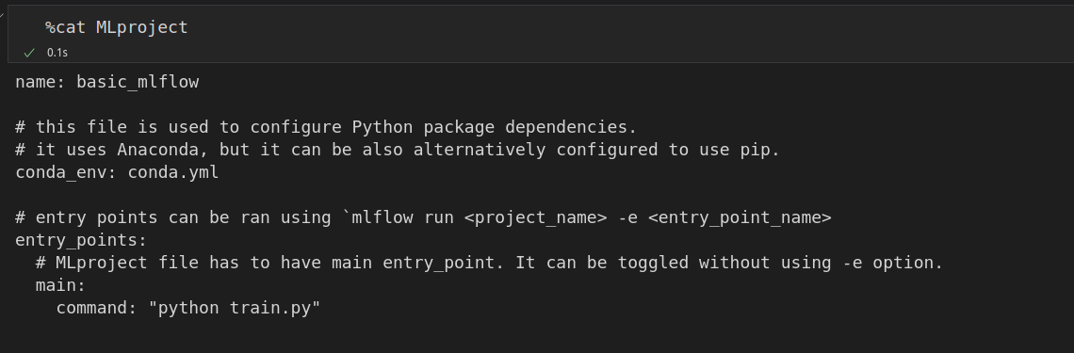
- Now we are Train the model.

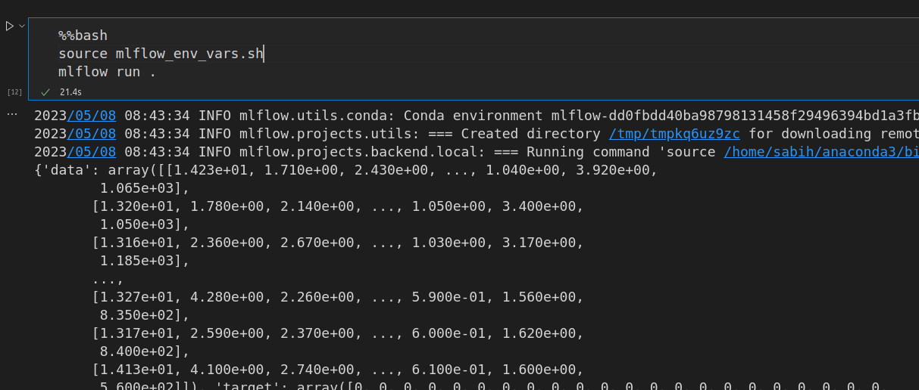
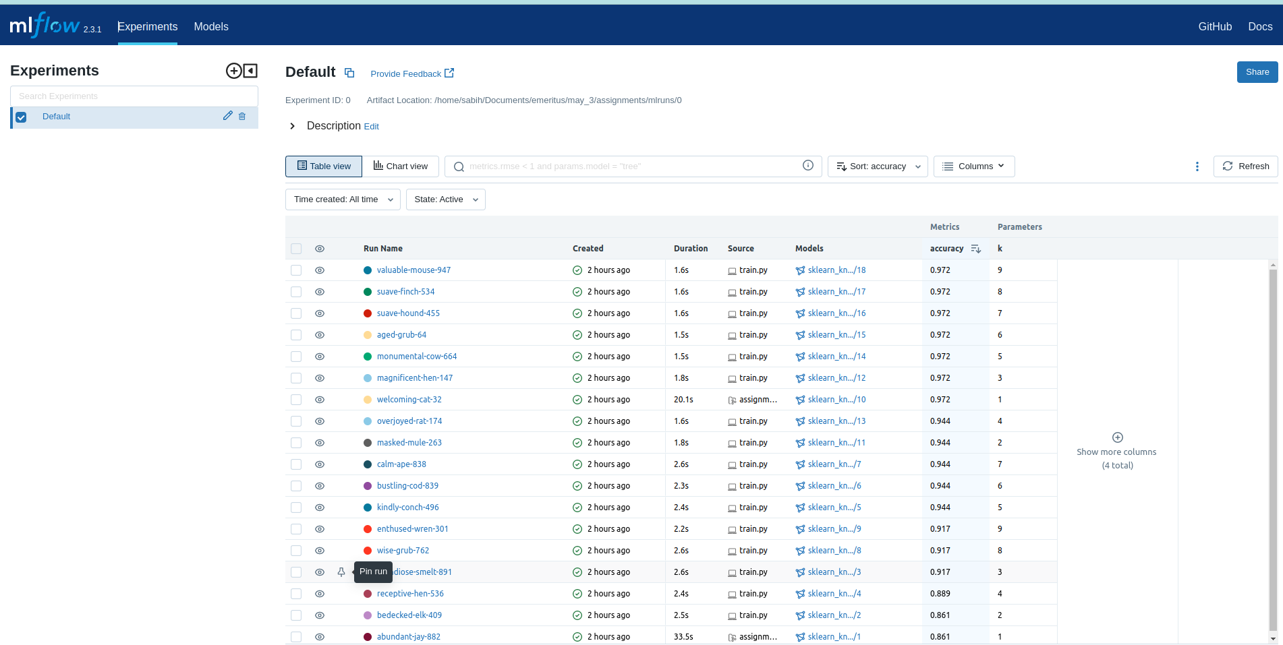

- Inspecting stored models The trained models are stored in `mlruns/0`.
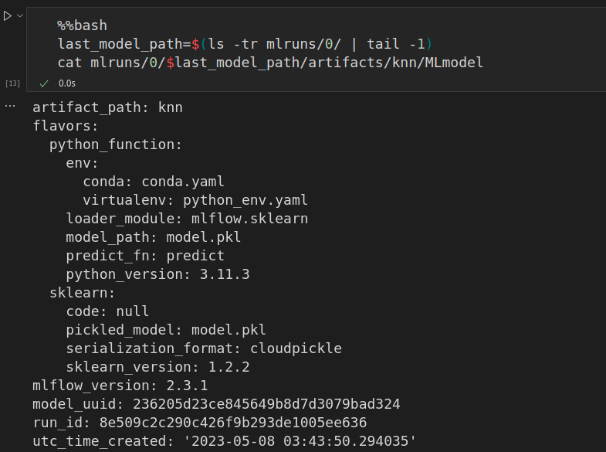
- Now we have to serve our model.
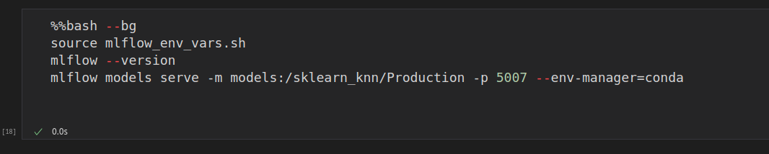

- Now to check our model we have to predict it.
